CHAPTER 8: Forces, energy and motion
Worksheet 8.6

Newton’s Second Law
Student: Class:
1. State Newton’s Second Law of Motion.

2. Use the formula F = ma to complete the following table
Force (F) (newtons) | Mass (m) | Acceleration (a)
100 | 40 kg
2 | 200 g
70 |  | 3.5 m/s²
100 |  | 10 cm/s²
3. Consider the forces acting on a body of mass 40 kg resting on a frictionless surface.
 | 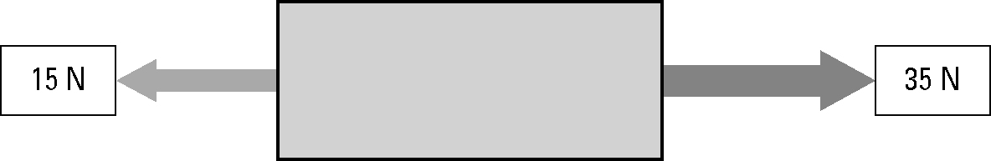 | (a) Calculate the net force acting  on the body.
(b) Calculate the acceleration of the body.

4. The photo shows a drag car coming to a stop at the end of a race.

Photo: Claudia Schnepf / 123RF
(a) To come to a complete stop, the drag car negatively accelerates. Identify another term for ‘negative acceleration’. ...................................................................
(b) Identify the force that brings the drag car to a stop. .....................................................................

